
My Target:
____ / or _____% Complete on the day of the test.   (Circle when your test is handed back)

Assessment 1 – Introduction to History (Year 7) 2023
In-class Short Answer Response (8%)

____ / 53
Name: __________________________

READING TIME – 5 Minutes WORKING TIME – 50 Minutes

Section 1 – Multiple Choice (10 marks)
*Please circle only ONE answer*

1. How many years is a millennium? (1 mark)

- A period of ten [10] years
- A period of a hundred [100] years
- A period of a thousand [1000] years
- A period of 1,000,000 years

2. A ‘primary source’ is: (1 mark)

- An item from primary school
- Any evidence that was created during the time period of study
- Any evidence that gives us insight in to the time period of study
- The first time you try tomato sauce

3. A ‘secondary source’ is: (1 mark)

- An item from secondary school
- Any evidence that was created during the time period of study
- Any evidence which analyses and interprets primary sources
- Sharing your sauce with a friend

4. A timeline is: (1 mark)
a) Something to do with clocks
b) A list of events in any order
c) A line displaying key events in chronological order
d) A line displaying key events

5. How can historians test the reliability of evidence from sources? (1 mark)
a) Ask a teacher
b) Ask Google
c) Check for bias
d) Compare them with other sources that are available

6. The concept of Significance would best be described as? (1 mark)

- The point of view of the author
- The reason why events occurred
- The importance that is assigned to particular aspects of the past
- That over time, some things change and some things remain the same

7. What best describes an artefact? (1 mark)

- items that have been made or changed by people
- natural items from the past
- animal remains
- myths and legends from the past

8. What do the sources we have for ancient Australia include? (1 mark)

- Papyrus, rock art and pottery
- Rock art and ruins of cities
- Statues and other rock art
- Oral history (stories) and archaeology (such as rock art and tools)

9. BC is also the same as: (1 mark)
- AC
- CE
- BCE
- AD

10. What are the missing words in the following sentence? (1 mark)

___________ is the situation when particular interpretations of the past are open to ________.

- Significance, interpretation
- Contestability, debate
- Contestability, decision
- Perspective, interpretation

Section 2 – Short Responses (43 marks)

- Define the historical concept of perspectives and provide an example. (3 marks)

_____________________________________________________________________________

_____________________________________________________________________________

_____________________________________________________________________________

_____________________________________________________________________________

- Define the historical concept of evidence and provide an example. (3 marks)

_____________________________________________________________________________

_____________________________________________________________________________

_____________________________________________________________________________

_____________________________________________________________________________

- Place the following dates in chronological order onto the timeline below: (4 marks)

356 BC 1989 CE 776 BCE 1AD 2250 BCE 1BC 2022 AD 1678 CE

- Categorise the following sources as either primary or secondary. State the word primary or secondary next to each type of source. Watch your spelling! (6 marks)

NAME OF SOURCE | PRIMARY OR SECONDARY SOURCE
A documentary on Otzi the Iceman which shows a re-enactment of how he died
The original diary of Anne Frank who experienced the holocaust in World War II
“Unlocking the Past”, a history textbook written in 2008
A letter from a World War I soldier sent to his family during the Gallipoli campaign.
The written biography on Cleopatra, published in 1978.
Inscriptions on the tomb of Ancient Egyptian Pharoah, Tutankhamun

- Outline the difference between primary and secondary sources, using examples. (6 marks)
_____________________________________________________________________________

_____________________________________________________________________________

_____________________________________________________________________________

__________________________________________________________________________________________________________________________________________________________________________________________________________________________________________________________________________________________________________________________________________________________________________________________________________________________________________________________________________________________________________________________________________________________________

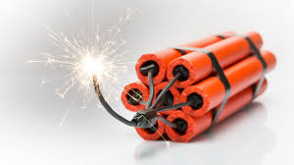
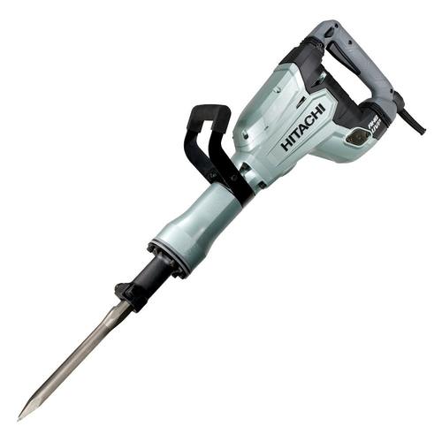
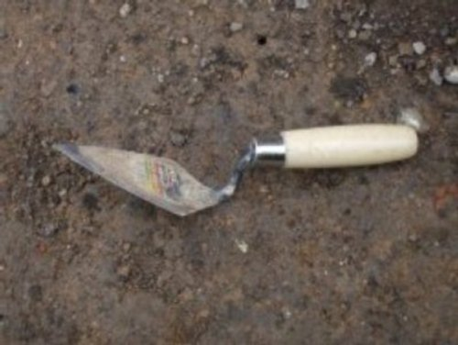
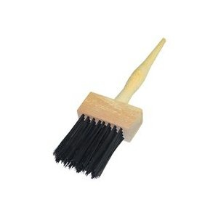
- Select two tools an archaeologist would most likely use to excavate an artefact from below. Outline why they would use this tool. (4 marks)

Dynamite
Jackhammer
Brush
Trowel
Tool 1:

_____________________________________________________________________________

_____________________________________________________________________________

_____________________________________________________________________________

_____________________________________________________________________________

Tool 2:

_____________________________________________________________________________

_____________________________________________________________________________

_____________________________________________________________________________

_____________________________________________________________________________

- Define relative dating with the use of an example. (3 marks)
_____________________________________________________________________________
_____________________________________________________________________________

_____________________________________________________________________________

_____________________________________________________________________________

- Define absolute dating with the use of an example. (3 marks)

_____________________________________________________________________________
_____________________________________________________________________________

_____________________________________________________________________________

_____________________________________________________________________________
- Select the correct term from the box provided below, to label each of the following descriptions relating to dating objects. (6 marks)

Stratigraphy Radiocarbon dating Fluorine dating
Relative dating Absolute dating Dendrochronology

- ____________________________: when an artefact is given a date because it is found in the same layer of earth(stratum) as another object that can be dated.

- ____________________________: used for any item that was once alive by measuring the level of carbon – 14 to date the age as carbon decreases at a fixed rate.

- ____________________________: a method that dates trees and wooden objects by counting growth rings. This can give information on past climate and to give a year when the tree was cut down and used to make the artefact.

- ____________________________: this form of dating gives an order of events in the past but does not give a precise year. It relies on the experience of the archaeologist and relative findings.

- _____________________________: this form of dating is used to date bones by measuring the amount of fluorine that the bone has absorbed from the soil.

- ____________________________: this form of dating is a more scientific and modern method using a wide range of ways to determine a more exact age.

10. Explain why the jobs of both a historian and an archaeologist are so important. *Extra writing space is provided on the next page if needed* (5 marks)
_____________________________________________________________________________

_____________________________________________________________________________

_____________________________________________________________________________

_____________________________________________________________________________

_____________________________________________________________________________

_____________________________________________________________________________

_____________________________________________________________________________

_____________________________________________________________________________

_____________________________________________________________________________

_____________________________________________________________________________

_____________________________________________________________________________

End of Assessment

